UNIVERSIDAD POLITÉCNICA DE MADRID
<Nombre oficial de la Escuela o Facultad, en español y sin abreviar>

<Title of the doctoral thesis, which must be identical to the title that appears on the THESIS platform>

DOCTORAL THESIS
Submitted for the degree of Doctor by:

<Name and Surnames>
<Previous academic degree>

Madrid, <year>
<Escudo de la Escuela o Facultad > |  | UNIVERSIDAD POLITÉCNICA DE MADRID  <Nombre oficial de la Escuela o Facultad, en español y sin abreviar>

Doctoral Degree in <Name of the doctoral programme, not abbreviated>

<Title of the doctoral thesis, which must be identical to the title that appears on the THESIS platform>

DOCTORAL THESIS
Submitted for the degree of Doctor by:

<Name and Surnames>
< Previous academic degree>

Under the supervision of:
Dr. <Name and Surnames>
<[Add co-supervisor if applicable]>

Madrid, <year>

Title: < Title of the doctoral thesis, which must be identical to the title that appears on the THESIS platform>
Author: <Name and Surnames>
Doctoral Programme: < Name of the doctoral programme, not abbreviated>
Thesis Supervision:
Dr. <Name and Surnames, position, institution> (Supervisor)
<[Add co-supervisor if applicable, including position and institution]>

External Reviewers: <delete this text to leave this field blank>

Thesis Defense Committee: <delete this text to leave this field blank>

Thesis Defense Date: <delete this text to leave this field blank>

< If the thesis has received funding from any competitive call, please state it here by writing: “This thesis has been partially supported by...”. Otherwise, delete this text to leave this section blank >

<Dedication (optional)>

Acknowledgement
<Acknowledgement page (optional)>

Abstract
<Abstract in English: maximum of 4000 characters, plain text (without symbols), structured summary of the thesis (introduction or motivation, objectives, findings and conclusions)>

Resumen
<Resumen en español: máximo de 4000 caracteres, texto plano (sin símbolos), resumen estructurado de la tesis (introducción o motivación, objetivos, hallazgos y conclusiones)>

Table of Contents

Acknowledgement v
Abstract vii
Resumen viii
List of Figures x
List of Tables xi
Abbreviations and Acronyms xii
1. Introduction 1
2. State of the art 3
2.1. How to use this template 3
2.2. Mandatory rules 3
2.3. Recommendations 5
3. Materials and methods 7
3.1. <Title of section> 7
3.1.1. <Title of subsection> 7
4. Results 9
4.1. <Title of section> 9
4.1.1. <Title of subsection> 9
5. Discussion 11
5.1. <Title of section> 11
5.1.1. <Title of subsection> 11
6. Conclusions 13
References 15
Annexes 17

List of Figures
Figure 2.1: Writing your thesis 6

List of Tables
Table 2.1: Components of the thesis document 3

Abbreviations and Acronyms

UPM | Universidad Politécnica de Madrid

Introduction

This template follows the thesis format of the Universidad Politécnica de Madrid (UPM), which are available here.
In the case of thesis by compendium of publications, its specific rules must also be respected, which are available here.
In the next chapter we provide more information about the rules for preparing the thesis document and the use of this template.

State of the art

How to use this template
This template has been developed in accordance with the UPM doctoral thesis formatting guidelines, which – in many respects – follow formatting standards common to many institutions.
The document is divided into three components (front matter, main matter and end matter), each of which has several subcomponents, as shown in Table 2.1.

Table 2.1: Components of the thesis document
Components | Subcomponents
Front matter | Cover  Frontpage  Credits page  [Dedication, Acknowledgment]  Abstract/Resumen  Table of Contents  List of Figures  List of Tables  Abbreviations and Acronyms
Main matter | Introduction  Central chapters specific of each thesis  Conclusions
End matter | References  Annexes

Most formatting rules refer to the front matter, that is, the initial pages that appear before the chapters of the thesis (the main body of the thesis).
Mandatory rules and some recommendations are presented below.

Mandatory rules
The key rules to remember are:
- The first three pages (cover, frontpage, and credits page) must use the format specified in this template. If the doctoral program is interinstitutional, the coverage may vary (check the template to be used in this case).
- The initial pages are mandatory, except for dedication and acknowledgment.
- The thesis is submitted in electronic format (PDF).
- Language: the thesis can be written in Spanish or English.
- Page size: A4
- Numbering: The front matter – before the beginning of the chapters – uses Roman numbering, with the page numbers centred at the bottom, excluding the cover and the frontpage, which should not be numbered. The rest of the text (starting with the Introduction) uses Arabic numbering, with the page numbers centred at the bottom.

The cover:
- It must be prepared using this template, entering the appropriate data in the sections marked with < > and without including other information.
- It must include the official name of the center, in Spanish and without abbreviation (see List).
- It must include the full name of the doctoral student.

The frontpage:
- It must be prepared using this template, entering the appropriate data in the sections marked with < > and without including other information.
- It must include the official name of the center, in Spanish and without abbreviation (see List). You can include the center logo, respecting the size indicated in the template (see Logos).
- It must include the full name of the doctoral program (see List).
- It must include the full name of the doctoral student.
- It must include the full name of the thesis director (and the co-director if there is one).

The credits page (page i):
- It must be prepared using this template, entering the appropriate data in the sections marked with < > and without including other information.
- Includes additional data on the thesis director: position and institution (the same for the co-director if there is one).
- The sections “External Reviewers”, “Thesis Tribunal” and “Defense Date” are left empty.
- If the thesis has received funding from any competitive call, it must be indicated at the end of this page (see template).

The summary:
- An abstract must be included in both Spanish and English, regardless of the language of the thesis.
- Format: maximum 4000 characters, plain text (no symbols).
- Structure: the abstract is a presentation of the thesis and, therefore, it must have a clear structure, including introduction (or motivation), objectives, development and conclusions.

Recommendations
Generally, the main body of the thesis covers several chapters, whose number and structure may vary depending on the field of knowledge and whether it is a manuscript or a thesis by compendium of publications. As a guide, this template includes the following chapters: Introduction, State of the art, Material and methods, Results, Discussion and Conclusions. The structure of the main body of each specific thesis should be consulted with the thesis supervisors.
Ideally each chapter is organized into sections and subsections, with numbered headings.
As for the font, the recommended styles are Times New Roman, Century, Arial, Book Antiqua, or similar.
Using a template helps to use the same format throughout the entire thesis. It is advisable to always use the same style to include citations in the text, as other authors also recommend (Bell, 2010; Carter & Kumar, 2017; Odena & Burgess, 2017; Rivera Camino, 2014), to format tables (see Table 2.1) and for format figures (see Figure 2.1). It is recommended to number tables and figures by chapters (Table 1.1, etc.).

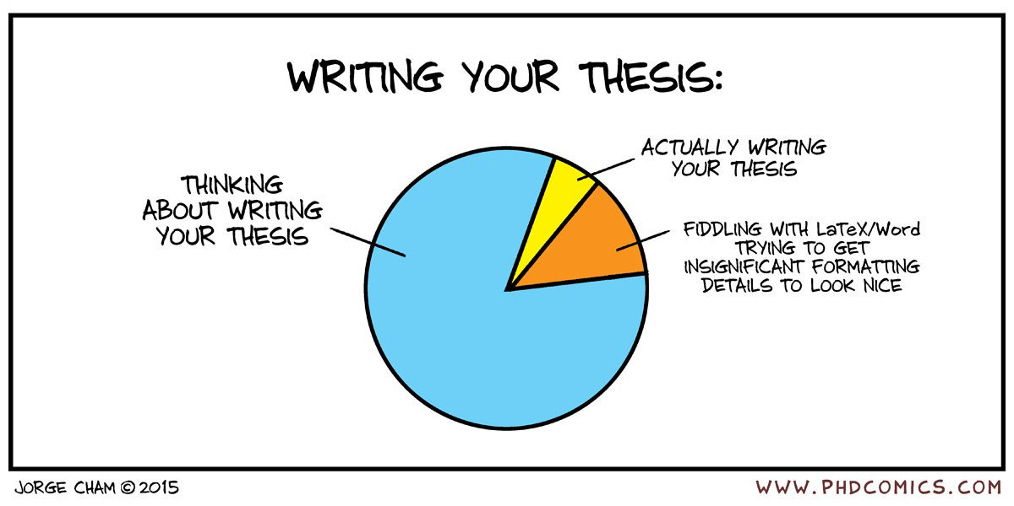
Figure 2.1: Writing your thesis

The final part of the thesis includes references and annexes.
References should be included using the style recommended for each field of knowledge. This template uses APA, but each thesis should use the standard style in its field of knowledge.
The annexes include additional material not included in the main text (questionnaires, additional results, etc.). It is recommended to number the annexes alphabetically (A, B, ...) and start each annex on a different page. In case of including tables in annexes, a new numbering will be used independent of that of the body of the thesis (Table A.1., etc.).

Materials and methods

<Title of section>

<Title of subsection>

Results

<Title of section>

<Title of subsection>

Discussion

<Title of section>

<Title of subsection>

Conclusions

References

Bell, J. (2010). Doing your research project: A guide for first-time researchers in education, health and social science (5. ed). McGraw-Hill, Open Univ. Press.
Carter, S., & Kumar, V. (2017). ‘Ignoring me is part of learning’: Supervisory feedback on doctoral writing. Innovations in Education and Teaching International, 54(1), 68–75. https://doi.org/10.1080/14703297.2015.1123104
Odena, O., & Burgess, H. (2017). How doctoral students and graduates describe facilitating experiences and strategies for their thesis writing learning process: A qualitative approach. Studies in Higher Education, 42(3), 572–590. https://doi.org/10.1080/03075079.2015.1063598
Rivera Camino, J. (2014). Cómo escribir y publicar una tesis doctoral (2a edición). ESIC Editorial.

Annexes

